**Systems Analysis and Testing**

**Phase I Group Submission**

**CAGroup 2**

**D22127275 - Jara Rodriguez**

**D22124468 - Stifnes Samuel**

**D22125624 - Aishanjiang Xierzhati**

**D22125495 -Yuanshuo Du**

Table of Content

Phase I Group Submission 1

D22127275 - Jara Rodriguez 1

D22124468 - Stifnes Samuel 1

D22125624 - Aishanjiang Xierzhati 1

D22125495 -Yuanshuo Du 1

1 General Project Information 1

1.1 Introduction 1

1.2 Project Details: 1

2 Research 2

2.1 Common features 2

2.2 Competitor analysis 2

2.3 Scope Statement 16

3 Use Case Diagram 18

4 Non-functional requirements 18

Performance Efficiency: 19

# General Project Information

## **Introduction**

Food delivery is a fast-growing and competitive market in Ireland. According to Statista(Statista, n.d.), the revenue in the online food delivery market is projected to reach US$1.07 billion in 2023, with an annual growth rate of 9.85%. The COVID-19 pandemic has also increased the demand for convenient and safe food delivery services(Irish food board, 2020). However, there are still many challenges and opportunities for new entrants in this market.

The project is to develop a food delivery application for the Irish market, allowing customers to browse for nearby meals and order services online. There are some reason why we choose developing a food delivery app:

Convenience: One of the primary reasons why people use food delivery applications is convenience. With just a few taps on their smartphones, users can order food from their favorite restaurants without having to leave their homes or offices.

Time-saving: Another reason why food delivery apps are popular is that they save time. Busy professionals and students who don't have time to cook or go out to eat can use food delivery apps to get their meals delivered to them quickly and easily.

Variety: A food delivery app offers users access to a wide range of restaurants and food options, making it easy to find and order the food they crave.

Contactless delivery: In the wake of the COVID-19 pandemic, contactless delivery has become an important feature for food delivery apps. With contactless delivery, users can receive their food without having to interact with the delivery person, reducing the risk of transmission.

## **Project Details:**

Our food delivery app will be designed to meet the needs of consumers in Ireland who are looking for a convenient and reliable way to order food online. The app will offer a user-friendly interface that allows users to search for restaurants, browse menus, place orders, and track deliveries.

The app will also feature a rating system that allows users to rate restaurants and delivery drivers based on their experiences. This system will help users make informed decisions about where to order food from and provide feedback to restaurants and drivers to improve their services.

We will partner with a wide range of restaurants across Ireland to offer users access to a diverse selection of cuisines and price points. The app will also offer contactless delivery options to ensure the safety of our users and delivery drivers.

In conclusion, our food delivery app will provide a convenient, time-saving, and reliable solution for consumers in Ireland who want to order food online. By partnering with restaurants and offering a wide range of food options, we aim to become the go-to food delivery app in Ireland.

# Research

Due to the scope of the project, the main functionalities researched were registering/logging in, browsing for a restaurant and items, and ordering an item. The competitors that were researched were DoorDash, Deliveroo, Uber Eats, and FoodPanda.

## **Common features**

Certain features were shared by most of the APPs I analysed. Here are some common technical features of food delivery apps from a functional perspective:

User account creation and management: All the competitors offer account creation and management features where users can register, login, view/edit their profile information, and manage their orders and payment methods.

Menu browsing and search: Users can browse the available menus of the restaurants, filter/search the menu items based on various criteria such as cuisine, restaurant, price, rating, etc.

Ordering and payment: Users can place an order for food and pay for it through the app using various payment methods such as credit/debit cards, PayPal, Google Pay, etc. Most of the apps offer cash on delivery as well.

Real-time order tracking: All the competitors provide a feature to track the real-time status of the order, which includes the order confirmation, preparation, and delivery status.

Rating and review system: Most of the apps offer a rating and review system where users can rate the restaurant and food and leave feedback to help other users make informed decisions.

Customer support: All the apps offer customer support features such as chat support, phone support, and email support to assist users in case of any issues related to orders, payments, etc.

## **Competitor analysis**

### DoorDash (<https://www.doordash.com/>)

DoorDash is the main food delivery platform in the United States, capturing an estimated 65% of sales. This glutinous giant was a good starting point to begin research into the functionality that our service could provide.

#### Registering and logging in

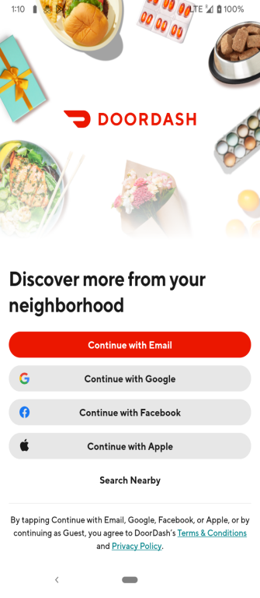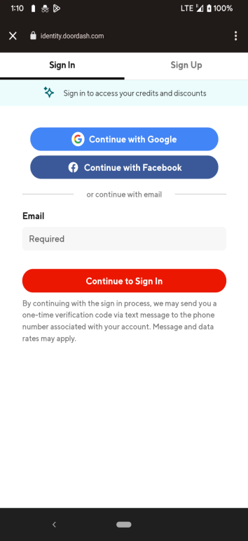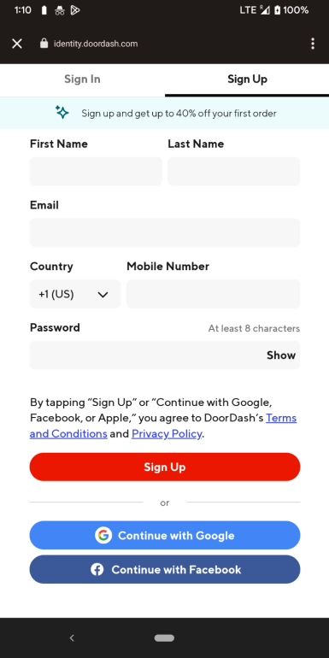

The registration process is exceedingly simple, requiring only a name, email, phone number, and a password to create an account. Alternatively, an account can be created through Google or Facebook. Once the account is created users can either stay signed into their device,log in using their email and password, or through a 3rd party if they were used during registration.

#### Browsing functionality

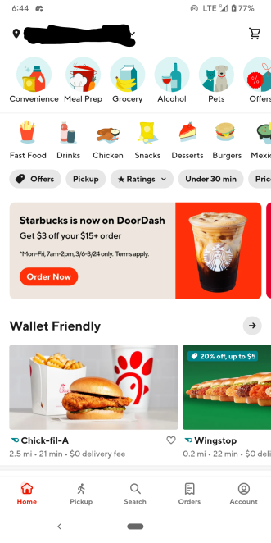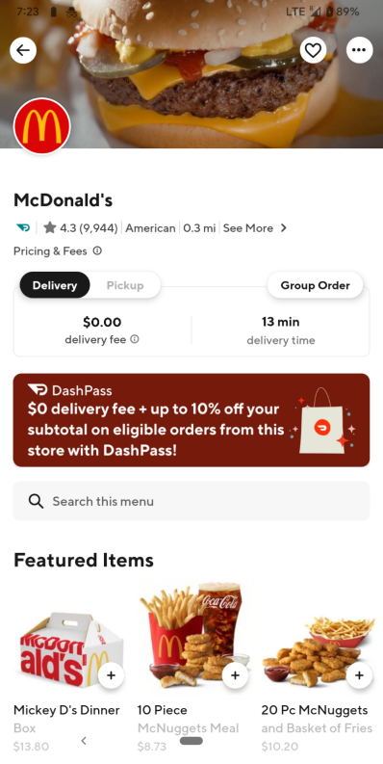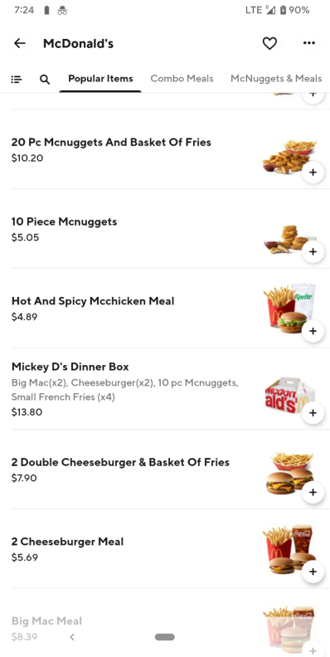

DoorDash offers many options to their customers for browsing through restaurants and items. At the top of the app are three banners that allow a user to choose between what they want delivered (doesn’t even have to be food!), cuisine, and other miscellaneous qualities such as delivery time/location and restaurant ratings. Food items within a restaurant are found through a featured list, a list of every available item that takes time to scroll through, or a banner that categorizes items. For both restaurants and food items there is a search bar that allows users to directly search for what they are looking for.

#### Ordering functionality

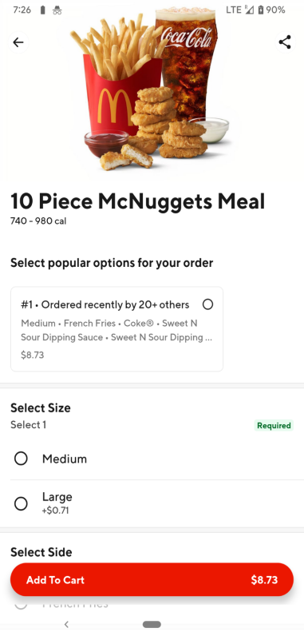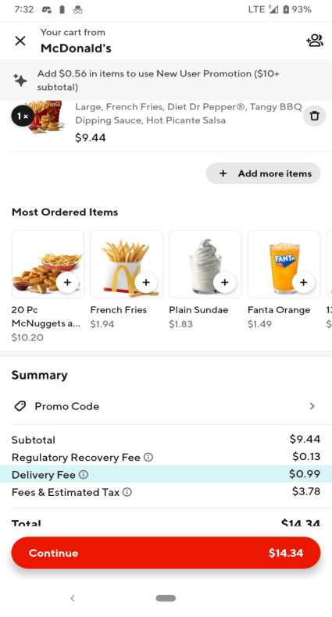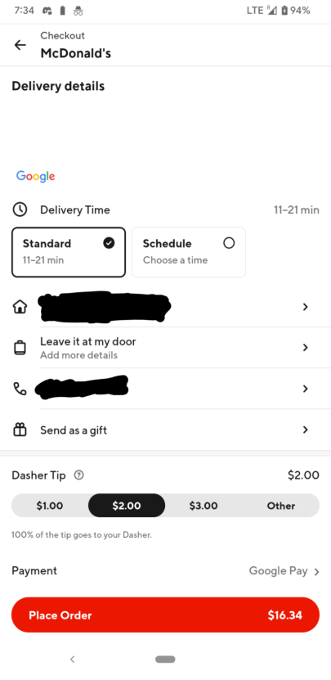

DoorDash ordering is simple, as a user only has to find item(s) that they want and add them to their cart, where they can easily adjust the order as needed. Once finished users can add more items or head to checkout. At checkout there’s a high degree of control for users, allowing them to change locations, phone numbers, tip, payment options, schedule orders, and view delivery times and distance. After the order is placed, the user can either wait for the food to arrive, or track the progress of the order in real-time.

### Deliveroo ([www.deliveroo.ie](http://www.deliveroo.ie))

#### Registration/Login Function:

1. **Social media integration.** Deliveroo allows users to register and log in with their Facebook or Google accounts, which simplifies the registration process.
2. **Magic link.** A magic link is a form of password-less login. Users don't need to enter any login credentials to sign in. Instead, an email is sent to them with an embedded token URL that is valid for ten minutes. Once the user clicks on the link for verification, they are redirected to the website, where they are automatically logged in. This feature simplifies the user login and registration process, and greatly improves security. However, if using the mobile app, the Magic link feature is not available, and users need to verify their phone number after entering their email, which makes the mobile app less user-friendly.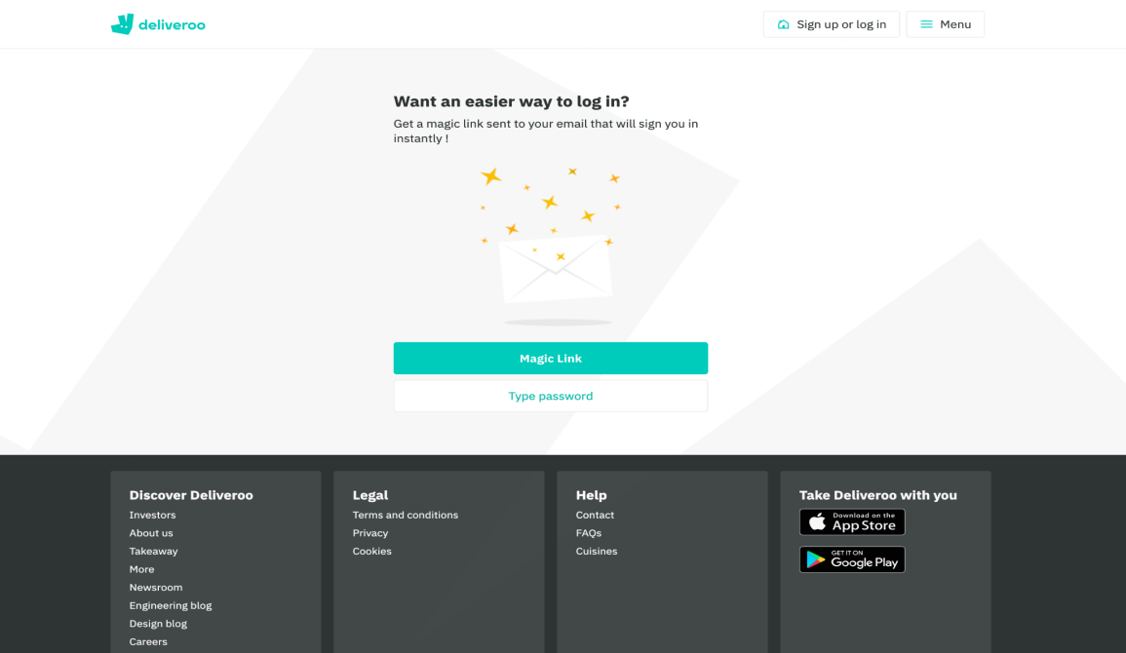
3. **Email registration.** For users who need it, the traditional email registration method is still available. Even with the use of the Magic link, users can still set passwords and link their Google, Facebook account, and phone number after logging in. Especially for users who use the software for the first time, the cumbersome registration and login process may cause them to lose interest.

#### Browsing Function:

1. **Searching.** Deliveroo provides a search bar on its website and app, allowing users to search for specific menu items, restaurants, and address selections. There are also filters to help users refine their search results, including sorting methods, special offers, dietary restrictions, dish types, and pickup/delivery times.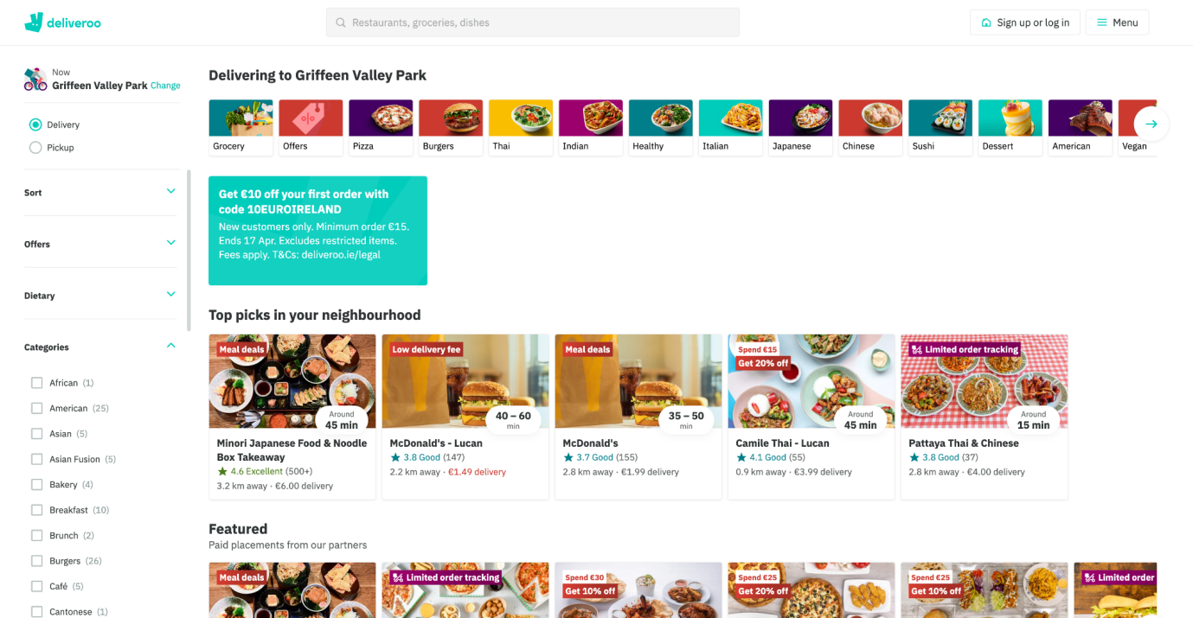
2. **Menu display.** On the homepage, Deliveroo displays the menu in a clear and organised way, showing the types of food categories at the top. The menu categories include "Top picks in your neighbourhood", "Offers near you", "Most favourited places", "New on Deliveroo", "Everyday low delivery fees", and "Top-rated". They also show photos of menu items and provide a brief description of each item, making it easier for users to understand what they are ordering.
3. **Menu item details.** It displays detailed information about menu items, including food ingredients and costs. Users can also choose to save their favourite dishes and restaurant.
4. **User reviews.** After choosing a restaurant, users can see the customer ratings and the number of reviews at the top, but whether on the website or mobile app, there is no way to view the customer reviews in detail. However, the design of the page may give users the illusion that they can click it and view the reviews, which can confuse customers and lead to a poor user experience.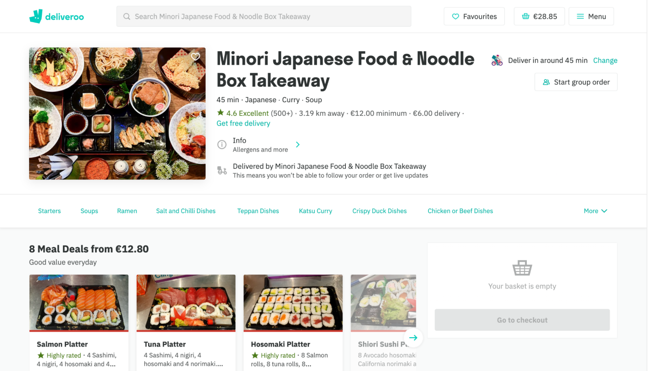

#### Ordering Function:

1. **Menu item selection.** Deliveroo enables users to select menu items through checkboxes and drop-down menus. On the checkout page, users can view the price, service charge, and delivery fee for their order. Additionally, a small order fee may be charged if the dish price is too low.
2. **Customisation options.** Deliveroo allows users to customise their orders, such as adding or removing toppings or side dishes. Users can also make notes or choose different dishes if they have allergens.
3. **Basket function.** Deliveroo provides a clear and concise summary of the user's order in the shopping basket and allows them to edit their order before checkout.
4. **Payment options.** Deliveroo offers multiple payment options, including credit cards, Apple Pay, gift cards, and Klarna (instalment payment software). Users can also enter discount codes. They also provide an option for users to save their payment information for future orders.
5. **Order confirmation.** Deliveroo provides an estimated delivery time for users and sends a confirmation email after placing the order.

#### Other Function

1. **Delivery tracking.** It offers real-time delivery tracking, allowing users to monitor their orders' progress and receive updates on estimated delivery times.
2. **Loyalty programs.** Deliveroo provides a loyalty program called Deliveroo Plus, which offers users free delivery and other benefits for a monthly fee. Currently, they have partnered with Amazon Prime and are offering a free year of Deliveroo Plus membership to Amazon Prime members. This not only enhances the user experience but also incentivises users to order repeatedly, improving customer retention.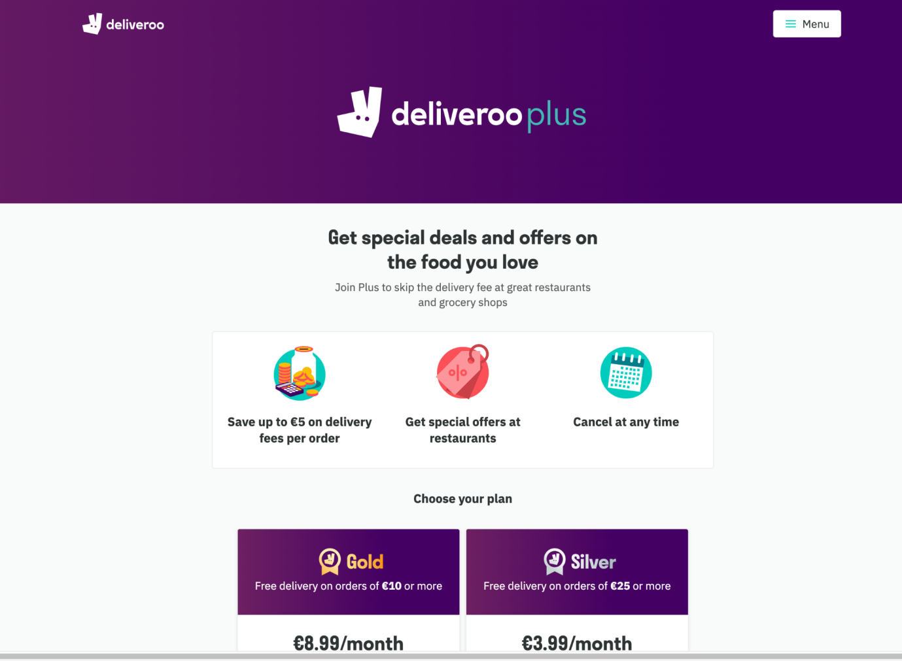

### Uber Eats

Uber Eats is an online food ordering and delivery platform that connects customers with a wide range of local restaurants. The platform was launched by Uber, the ride-sharing giant, in 2014, and has since become one of the leading food delivery services globally. Uber Eats operates in more than 6,000 cities across 45 countries, and offers a vast selection of cuisines, including Italian, Chinese, Indian, Mexican, and American, among others.

Uber Eats is a popular online food ordering and delivery platform that provides customers with access to a wide range of local restaurants. The platform offers a user-friendly interface, a vast selection of cuisines, and fast delivery times. Additionally, Uber Eats has a range of features that make it easy for customers to browse menus, place orders, and track their delivery in real-time. Despite some limitations, such as limited availability in certain regions and occasional issues with delivery times, Uber Eats remains a top choice for customers looking for convenient and reliable food delivery services.

#### Registration/Login Function:

**Sign in with existing Uber account or create a new one**: Users who already have an Uber account can use the same credentials to sign in to Uber Eats, saving them the hassle of creating a new account. Alternatively, they can create a new account specifically for Uber Eats.

**Multiple sign-in options:** The app offers various options for sign-in, such as email, phone number, Facebook, Google, and Apple ID, making it easy for users to use their preferred sign-in method.

**Biometric authentication:** Users can use biometric authentication such as fingerprint or face ID for added security when logging into the app.

**Cashless transactions:** The app is designed to be cashless in most regions, meaning users need to link a payment method such as credit card, debit card, or PayPal to their account. This allows for a smooth, hassle-free payment process when ordering food.

#### Browsing functionality:

The Uber Eats app allows users to search for food or restaurants, browse through categories and recommendations, view menus and prices, place orders, track their status and location, receive notifications, rate and give feedback, and use coupons and a points system.

**Search functionality:** Users can enter the name of the food or restaurant they want in the search box, or browse through different categories and recommendations, making it easy to find what they're looking for.

**Restaurant information:** The app displays menus, prices, reviews, delivery times and costs, allowing users to choose their favorite dishes and make informed decisions about their order.

**View Ratings and feedback**: Users can rate and give feedback on their orders and deliverers, allowing them to share their experiences and provide valuable feedback to the app and other users. Users and restaurants can view the rates.

some limits for searching functions:

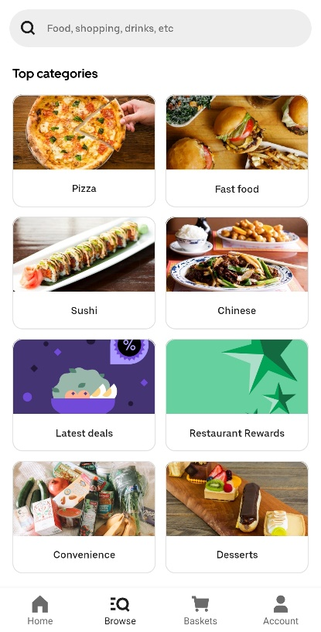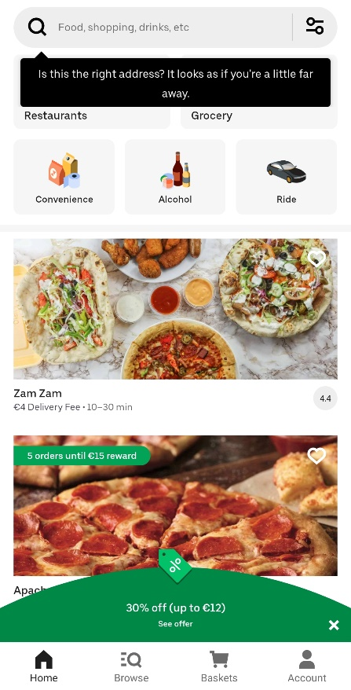

**Limited search filters**: While Uber Eats provides some search filters, such as cuisine type and distance, it lacks advanced filters like dietary restrictions, price range, and customer ratings.

#### Ordering Function:

**User select and confirmation:** In the Uber Eats app, users can search for restaurants and dishes, view menus and prices, and add items to their cart. Once they have confirmed their order, they can choose their preferred mode of payment, including credit card, debit card, or PayPal.

**Restaurant confirmation**: Once the user has confirmed their order, the restaurant receives a notification and can start preparing the food. The app provides an estimated delivery time for the user.

**Valet assignment:** Once the food is prepared, the delivery person is assigned to pick up the order and deliver it to the user. The app provides the user with information about the delivery person, including their name, photo, and rating.

**Real-time GPS tracking:** The app allows the user to track the location of their food and delivery person in real time. They can see the estimated delivery time and receive notifications about the progress of their order.

**Shopping cart:** The app allows the user to add items to their cart, view their total amount, and make changes to their order before confirming it. Users can also view their order history and reorder their favorite items with ease. 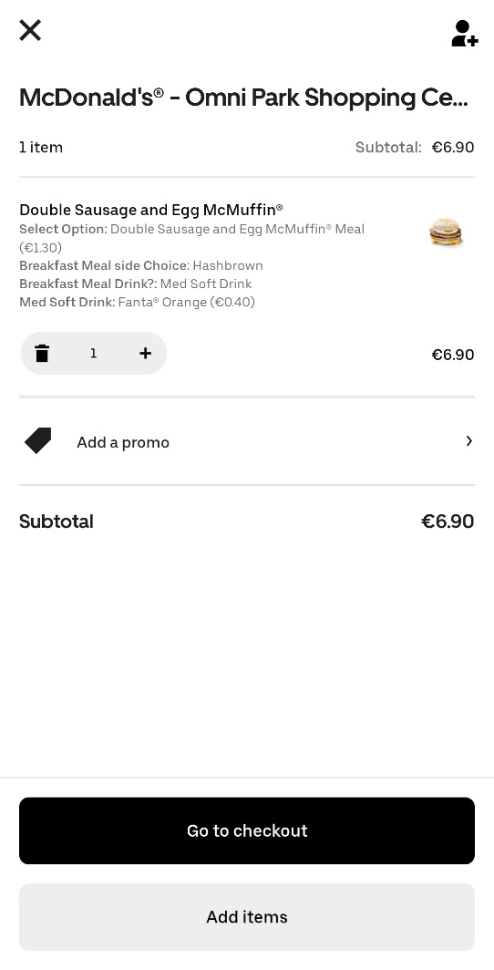

### FoodPanda (<https://www.foodpanda.com/>)

Foodpanda is the main food delivery system in South East Asian Countries and some European and other Asian regions.

Foodpanda is operating in 13 markets in Asia and four markets in Europe, including:

* Europe
  + Hungary
  + Slovakia
* East Asia
  + Hong Kong
  + Taiwan
* Southeast Asia
  + [Cambodia](https://en.wikipedia.org/wiki/Cambodia)[[37]](https://en.wikipedia.org/wiki/Foodpanda#cite_note-37)
  + [Laos](https://en.wikipedia.org/wiki/Laos)[[38]](https://en.wikipedia.org/wiki/Foodpanda#cite_note-38)
  + [Malaysia](https://en.wikipedia.org/wiki/Malaysia)
  + [Myanmar](https://en.wikipedia.org/wiki/Myanmar)
  + [Philippines](https://en.wikipedia.org/wiki/Philippines)
  + [Singapore](https://en.wikipedia.org/wiki/Singapore)
  + [Thailand](https://en.wikipedia.org/wiki/Thailand)
* South Asia
  + [Bangladesh](https://en.wikipedia.org/wiki/Bangladesh)
  + [Pakistan](https://en.wikipedia.org/wiki/Pakistan)

#### Registering and logging in

**Login Landing Page:**

As soon as a user lands on foodpanda country specific page. They are prompted with a login option on the right hand corner of the page.

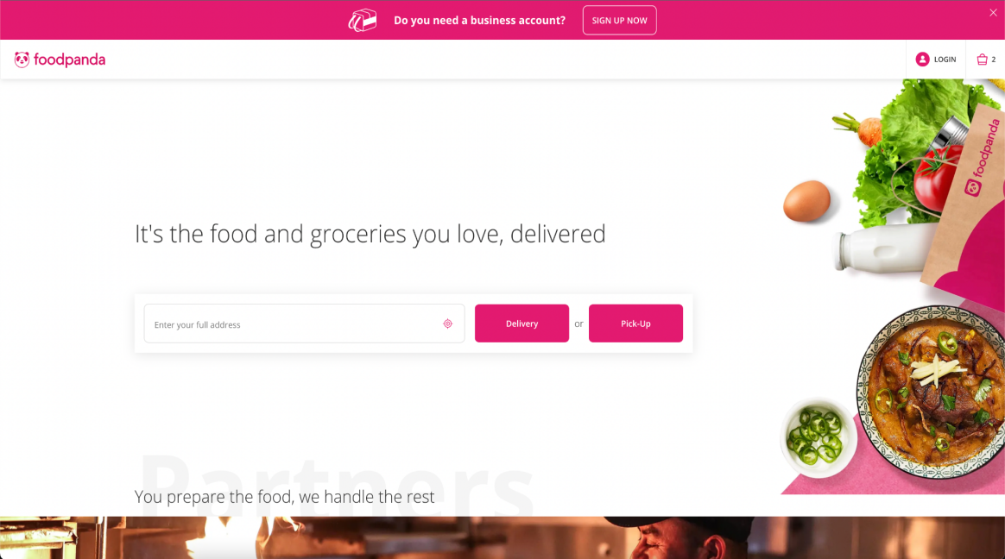

**Login and Registering Options:**

Users are given the option of login in or registering with either any social media platform (i.e Google, Apple or Facebook) or they can enter their email address manually along with their password.

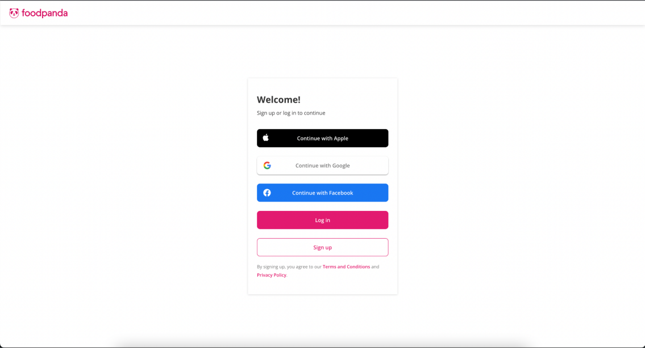

**Registering manually with email:**

If a user wants to register manually via entering their own email address. They are prompted with an input field which checks if the user is already registered or not.

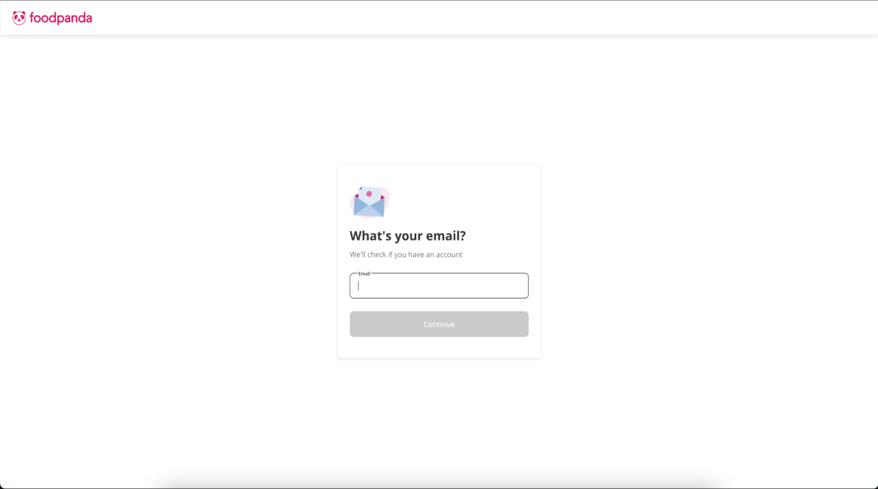

If the user is not registered a verification email is sent to them to verify their email account and after verification they can setup their account on foodpanda.  
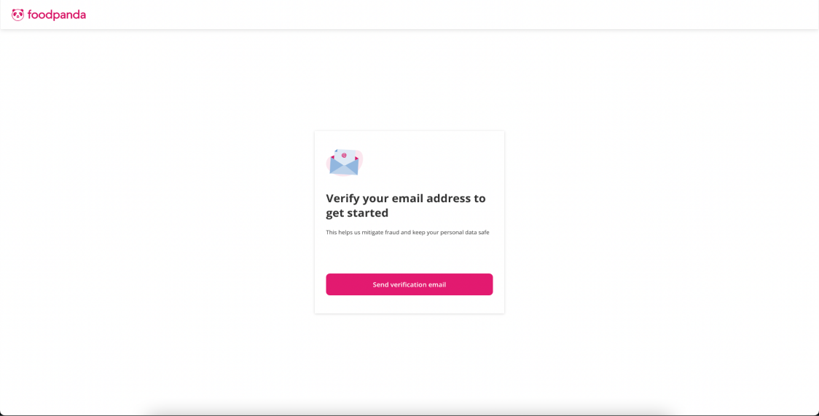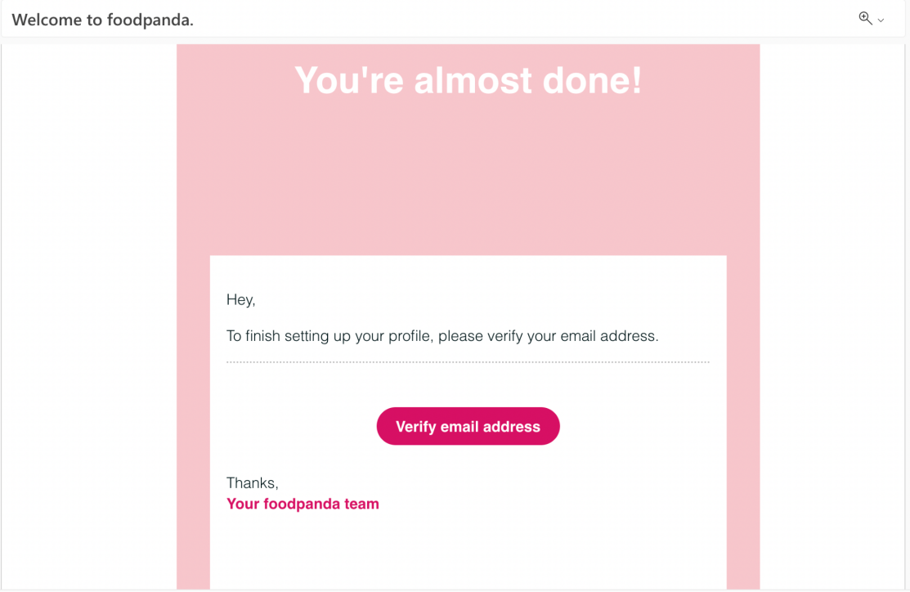

#### Browsing functionality:

There are two ways that a user can browse the food places /restaurants on foodpanda.

**Browse by location:**

A user can enter their location and the application will give all the restaurants which will deliver to that address or which will offer a pick up service from them.  
 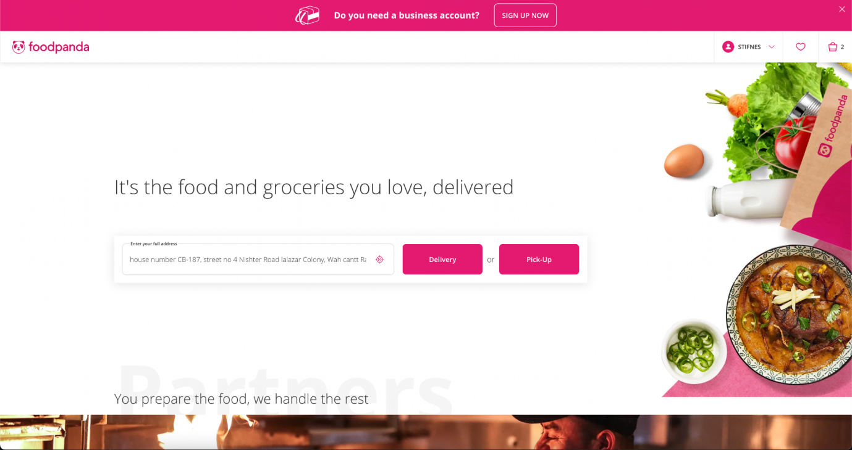

**Browse by City:**

A user can also browse the restaurants based on any city of their country:  
  
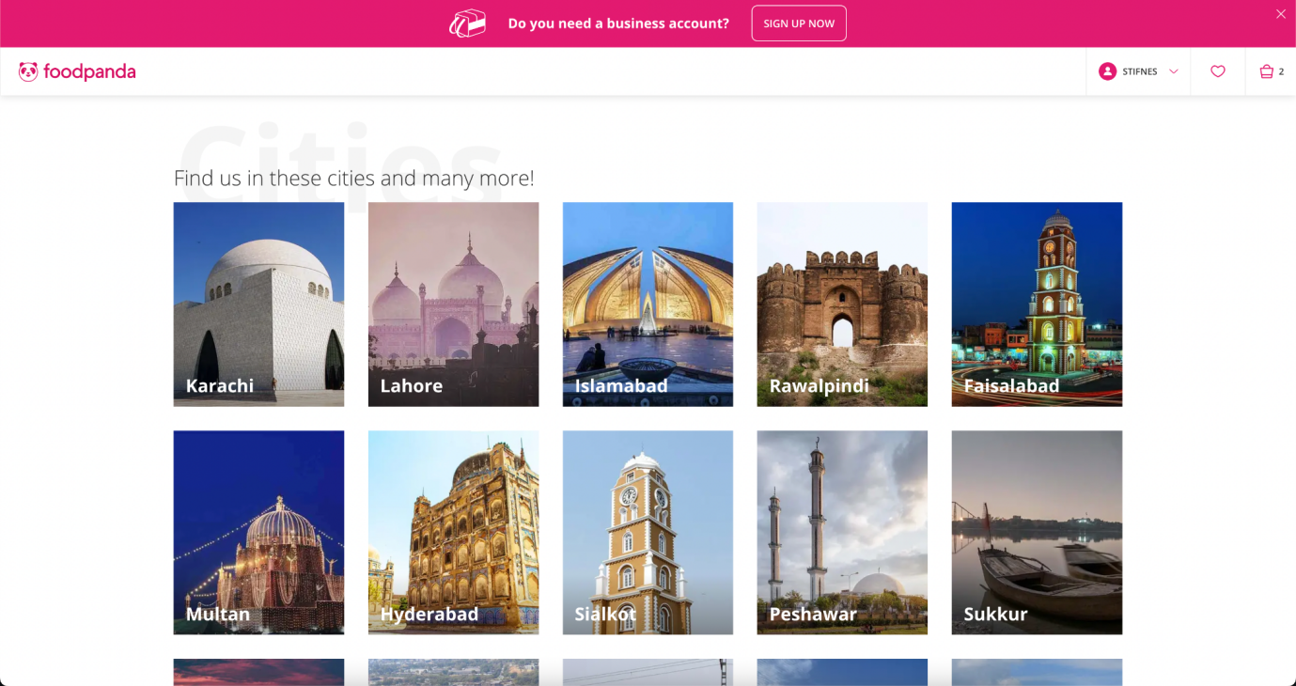

Browsing by either option will give the user a list of restaurants:  
 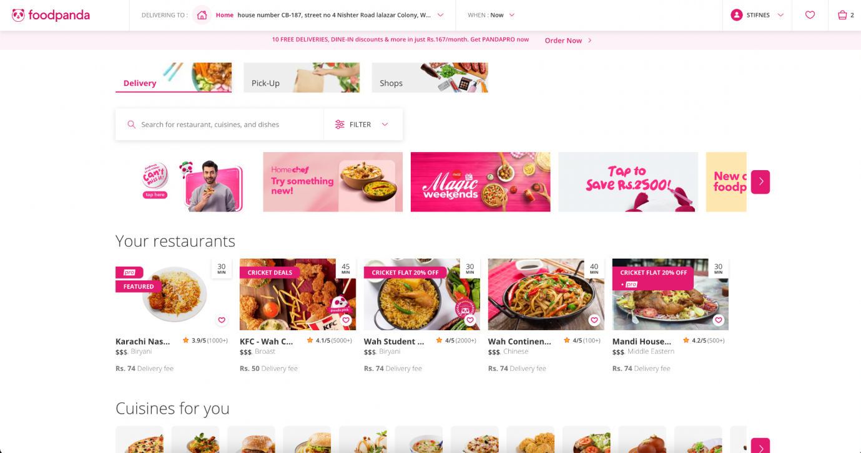

A user can filter the restaurants by selecting the filters dropdown:  
  
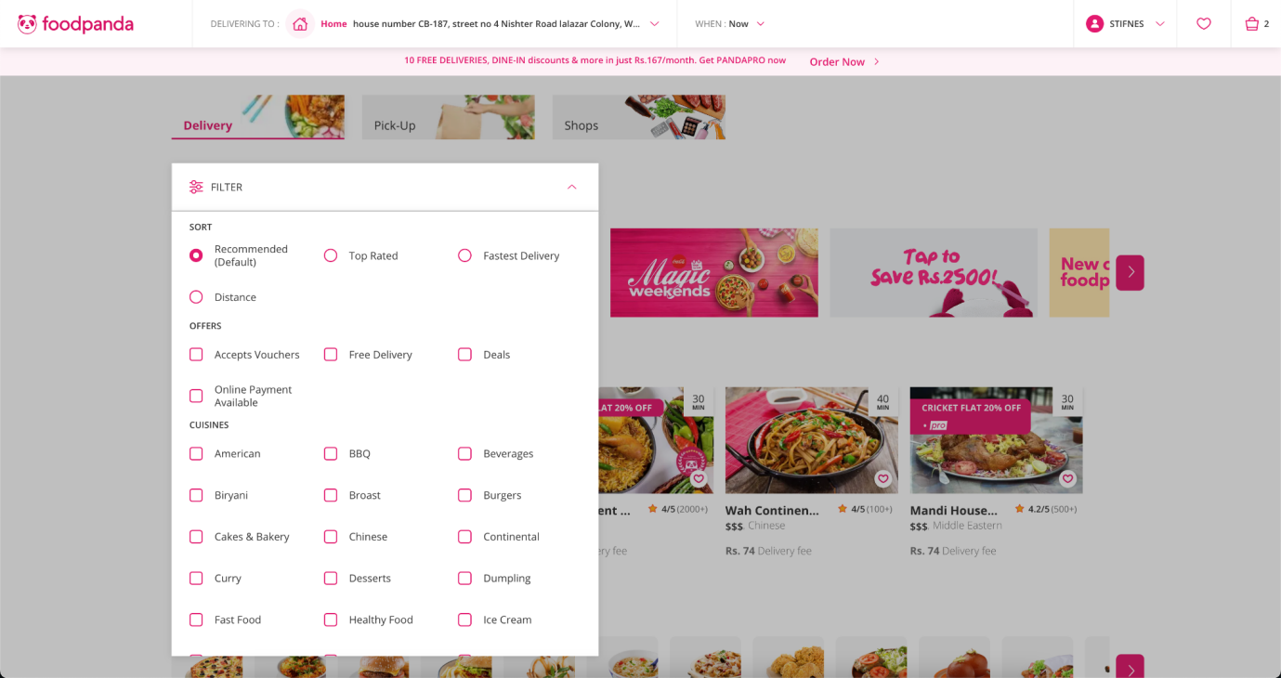  
  
Users can select any restaurant they like and select menu items and add them to cart.  
  
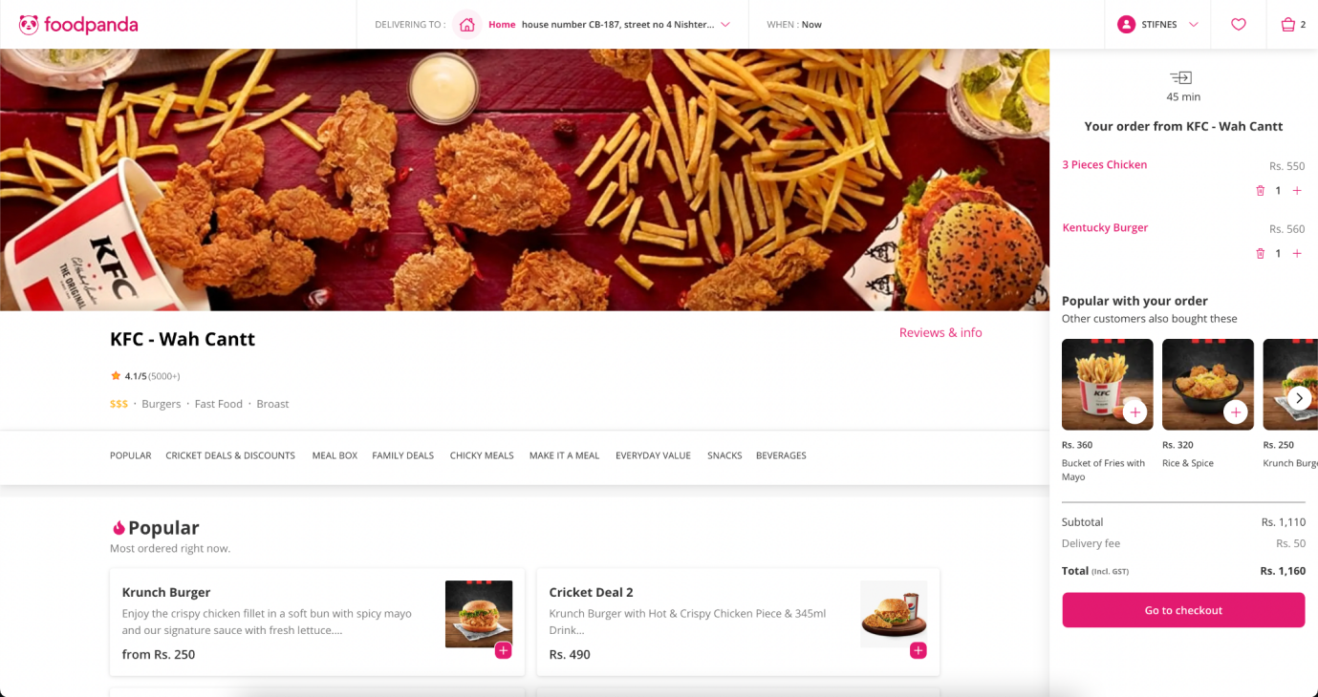

#### Ordering functionality:

**Selecting item**

Users can select any item and add them to their cart. They are redirected to the checkout page where they can enter their delivery, personal and payment details.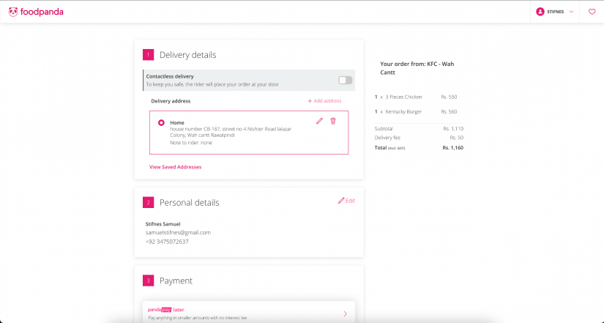

And finally can place their order.

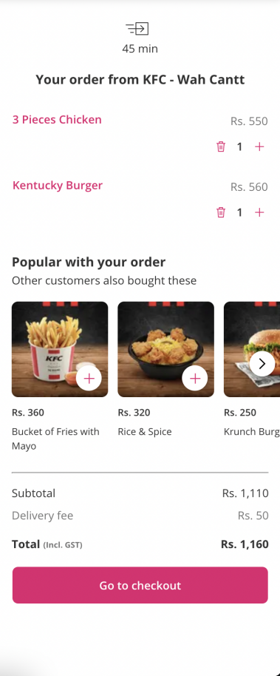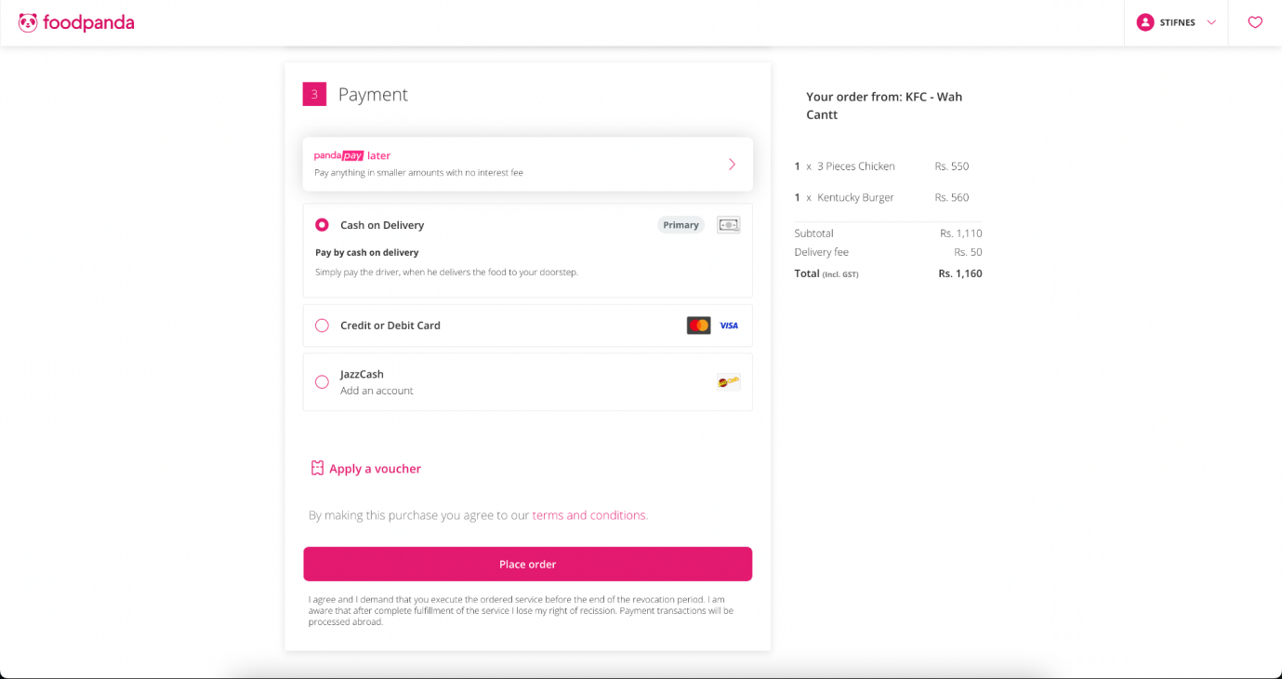

## **Scope Statement**

The project scope is to develop a food delivery application that allows customers to order food online and have it delivered to their doorstep. The application will be available in the Irish market, serving customers in various cities in Ireland. The application will allow restaurants to register with the platform and create their menu, including food items, pricing, and delivery options.

The application will offer customers the ability to browse restaurants, view their menus, and place orders. The customers will be able to customize their orders, including special requests and dietary preferences. The application will allow customers to pay online using a secure payment gateway, and they will receive real-time updates on the status of their order and delivery time.

The application will have a user-friendly interface, allowing customers to create and manage their profiles, view order history, and leave feedback and ratings for restaurants. The application will also offer a referral program to encourage customers to invite their friends to use the application.

The program scope includes the development and implementation of the food delivery application. The program will involve designing and developing the software, including the user interface, payment gateway, and database. The program will also include testing and quality assurance to ensure that the application meets the requirements and is bug-free.

The program will require the use of programming languages such as Java or Python, web development frameworks such as AngularJS or ReactJS, and database management systems such as MySQL or MongoDB. The program will also require the use of secure payment gateway APIs such as Stripe or PayPal.

The program will follow agile software development methodologies, including iterative development, continuous integration, and frequent testing. The program will involve collaboration among developers, testers, and project managers to ensure that the application is delivered on time and within budget.

### Assumptions/Constraints

* Restaurants will register with the website and provide information such as menu items, pricing, location, and delivery options.
* Customers can browse the website or app to search for restaurants, view menus, and place orders.
* The website or app will provide an interface for customers to track their order status and delivery.
* The website or app will integrate with third-party payment systems to process transactions securely.
* The system will ensure that orders are delivered within a reasonable timeframe and in compliance with food safety regulations.
* Delivery drivers will be available to deliver orders and will be paid a commission based on the number of deliveries completed.
* The system will allow customers to rate their delivery experience and leave feedback for restaurants and drivers.
* The system will not be responsible for any issues that arise with the quality or safety of the food delivered, as this is the responsibility of the restaurant.
* The scope of the project will be limited to a specific geographic region, such as a city or county.
* The system will not allow customers to cancel orders once they have been placed, unless agreed upon by the restaurant and the customer.
* The system will not facilitate group orders or corporate orders, and will only allow for individual orders.

### Possible Restrictions on the scope

* Geographical coverage: The application may be limited to certain areas or cities in Ireland, which could restrict the number of restaurants and customers using the platform.
* Menu items and restaurants: The application may only include certain types of cuisine or specific restaurants that meet certain criteria. This could limit the variety of food options available to customers.
* Delivery times: The application may have specific delivery times or cut-off times for ordering food, which could limit the flexibility of customers.
* Payment options: The application may only accept certain payment methods, such as credit cards or mobile payments, which could exclude some potential customers who prefer to pay in other ways.
* Order modifications: The application may have restrictions on customers modifying or cancelling orders once they have been placed, which could impact customer satisfaction and loyalty.
* Delivery distance: The application may have limitations on the maximum distance or delivery radius from restaurants, which could limit the number of potential customers or restaurants using the platform.
* Customer service: The application may have limited customer service options, such as only providing support via email or chat, which could impact customer satisfaction and retention.

# Use Case Diagram

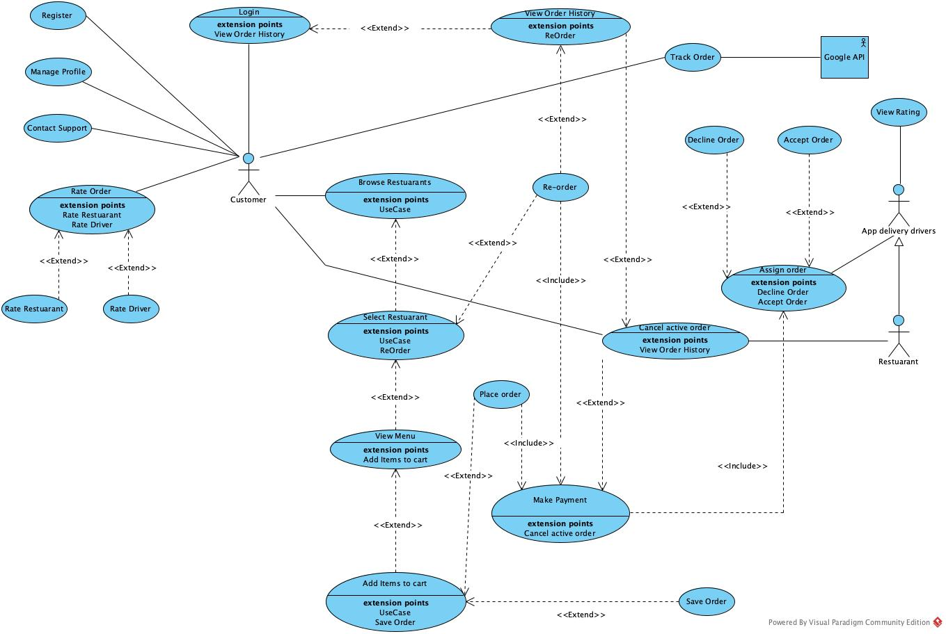

# Non-functional requirements

**Performance Efficiency:**

a. Response Time: The website should load quickly and process user inputs, searches, and transactions within a reasonable time frame.

b. Scalability: The website should be able to handle increased loads, such as a growing number of users, restaurants, and orders.

c. Throughput: The system should be able to process a high volume of orders and transactions simultaneously.

**Usability**:

a. User Interface: Design an intuitive, easy-to-navigate, and visually appealing interface for easy navigation and order placement. Also, supports accessibility for users with disabilities.

b. Mobile Compatibility: Ensure the website is responsive and works seamlessly on various devices, such as smartphones and tablets.

c. Localization: Support multiple languages and adapt to local preferences, units, and currency.

**Security:**

a. Authentication and Authorization: Authentication and Authorization: The website should have a secure login and registration process for users, restaurants, and delivery partners.

b. Data Protection: Use encryption to protect sensitive data, such as user passwords and payment information, both in transit and at rest.

**Reliability**:

a. Availability: The website should be available and operational 24/7, with minimal downtime to ensure users can always access it.

b. Data Backup and Recovery: Regularly backup data and establish a disaster recovery plan in case of data loss or system failure.

**Portability:**

a. Platform Independence: Design the website to be compatible with various operating systems and web browsers.

b. API Integration: Develop APIs to allow integration with third-party services, such as payment gateways, maps, and delivery tracking systems.

By addressing these non-functional requirements, our website and software will be better equipped to provide a high-quality user experience for users, restaurants, and delivery partners while meeting the demands of a competitive online food delivery market.